Xiyue Suo(001348347)

**Program Structures & Algorithms**

**Fall 2021**

**Assignment No. 2**

* **Task (List down the tasks performed in the Assignment)**

Part1: You are to implement three methods of a class called *Timer*. Please see the skeleton class that I created in the repository. *Timer* is invoked from a class called *Benchmark_Timer* which implements the *Benchmark* interface.

The function to be timed, hereinafter the "target" function, is the *Consumer* function *fRun* (or just *f*) passed in to one or other of the constructors. For example, you might create a function which sorts an array with *n* elements.

The generic type *T* is that of the input to the target function.

The first parameter to the first run method signature is the parameter that will, in turn, be passed to target function. In the second signature, *supplier* will be invoked each time to get a *t* which is passed to the other run method.

The second parameter to the *run* function (*m)* is the number of times the target function will be called.

The return value from *run* is the average number of milliseconds taken for each run of the target function.

Don't forget to check your implementation by running the unit tests in *BenchmarkTest*and*TimerTest*. If you have trouble with the exact timings in the unit tests, it's quite OK (in this assignment only) to change parameters until the tests run. Different machine architectures will result in different behavior.

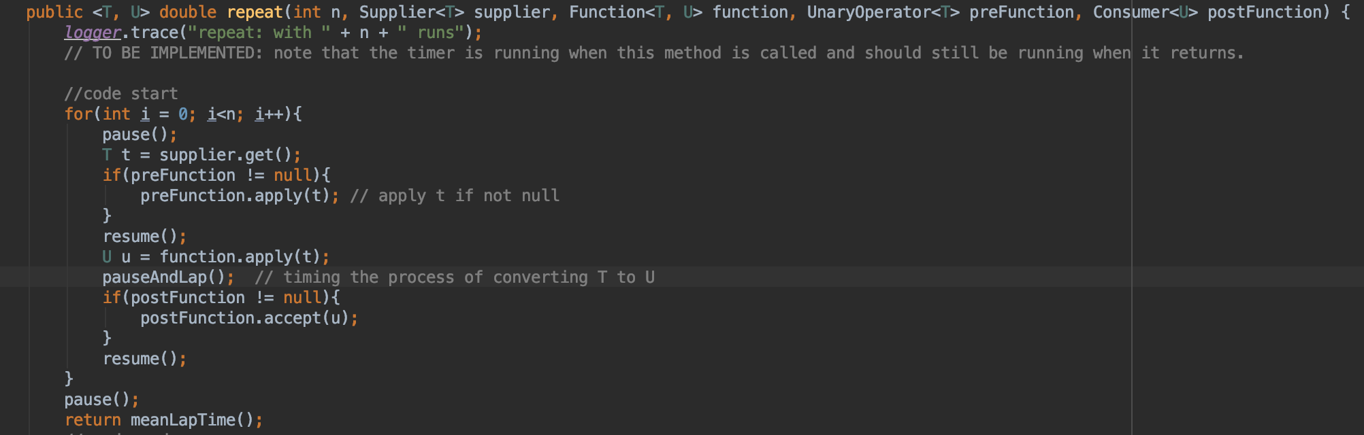

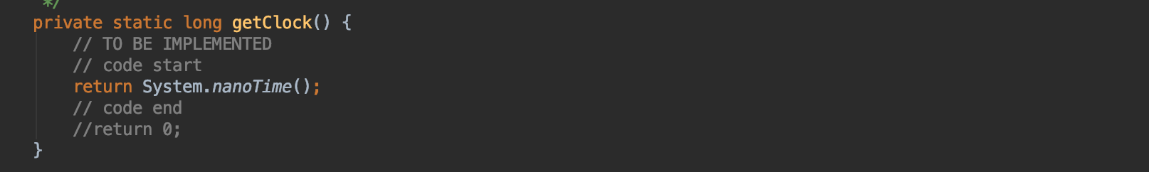

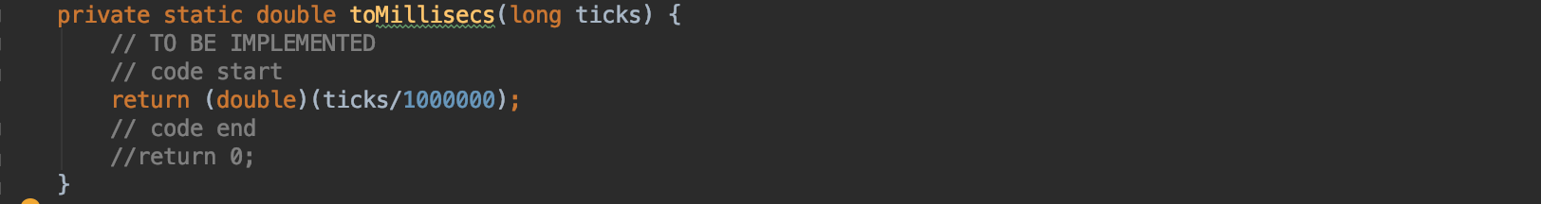

Part2:  Implement *InsertionSort*(in the *InsertionSort* class) by simply looking up the insertion code used by*Arrays.sort.* If you have the *instrument = true* setting in *test/resources/config.ini*, then you will need to use the *helper* methods for comparing and swapping (so that they properly count the number of swaps/compares). The easiest is to use the *helper.swapStableConditional* method, continuing if it returns true, otherwise breaking the loop. Alternatively, if you are not using instrumenting, then you can write (or copy) your own compare/swap code. Either way, you must run the unit tests in *InsertionSortTest*.

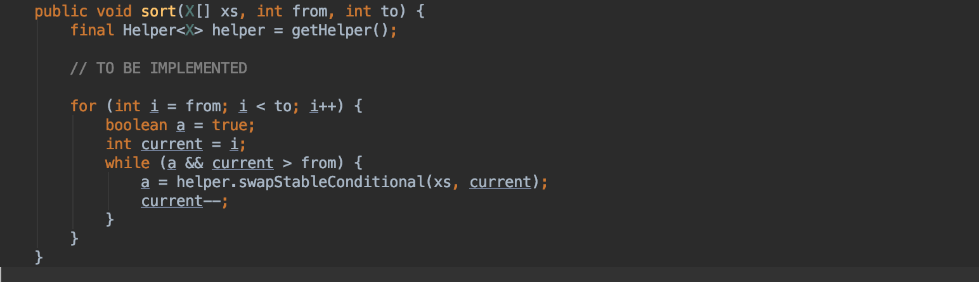

Part3: Implement a main program (or you could do it via your own unit tests) to actually run the following benchmarks: measure the running times of this sort, using four different initial array ordering situations: random, ordered, partially-ordered and reverse-ordered. I suggest that your arrays to be sorted are of type *Integer*. Use the doubling method for choosing *n*and test for at least five values of *n.*Draw any conclusions from your observations regarding the order of growth.

* Main method in the Benchmark_Timer class.

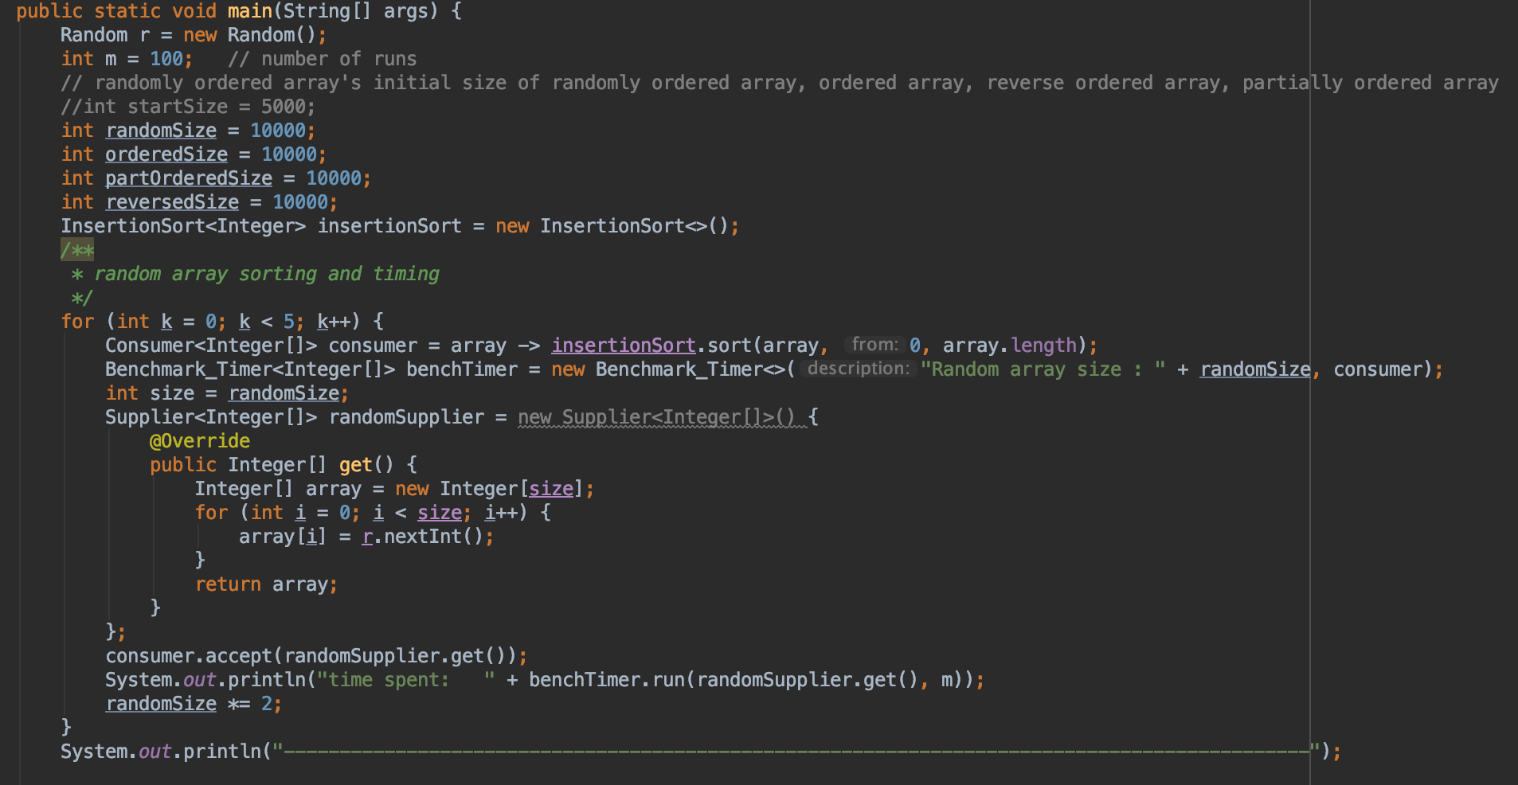

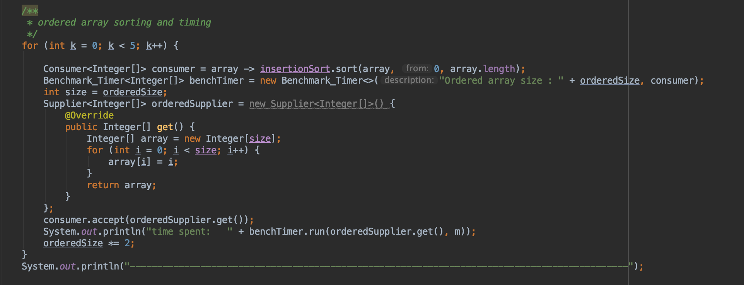

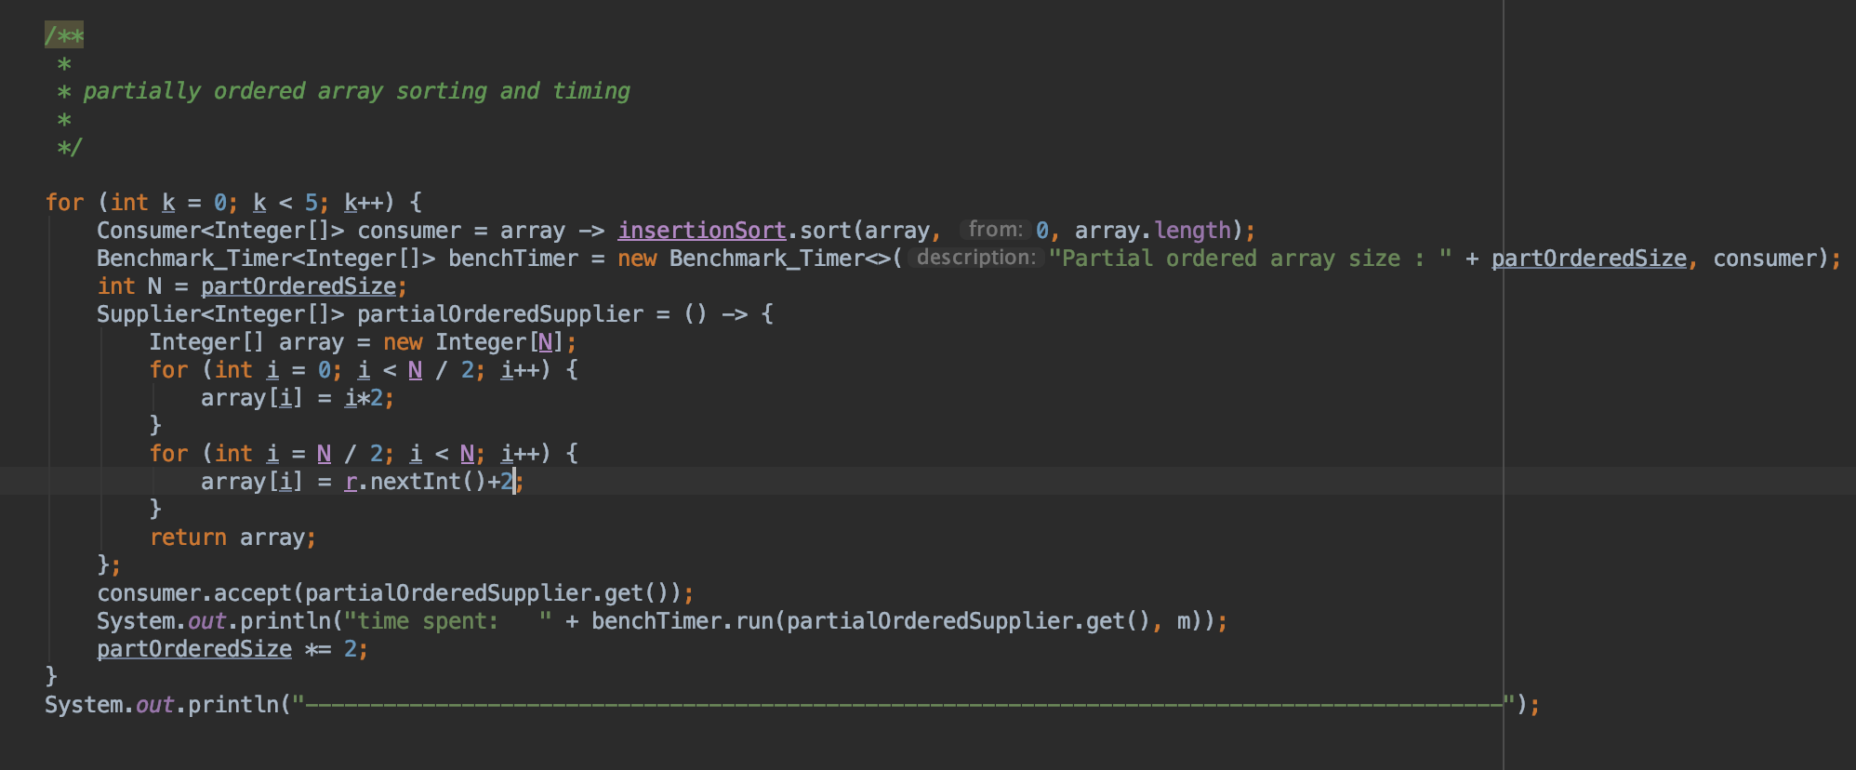

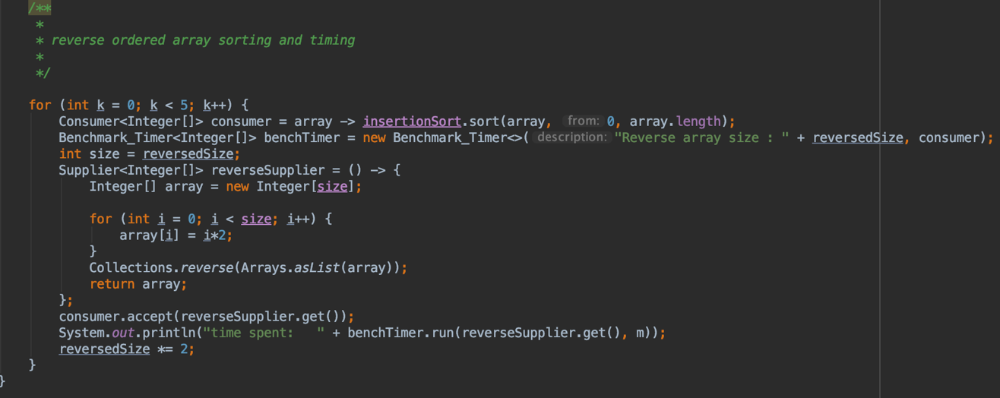

* **Relationship Conclusion: (For ex : z = a * b)**
  + The relationship I got for random array size and sorting time is: $t=2E-06n^{1.1373}$, where d is sorting time in ms, n is array size.
  + The relationship I got for ordered array size and sorting time is: $t=3E-06n^{1.0796}$, where d is sorting time in ms, n is array size.
  + The relationship I got for partially ordered array size and sorting time is: $d=5E-06n^{1.0401}$, where d is sorting time in ms, n is array size.
  + The relationship I got for reverse ordered array size and sorting time is: $d=3E-06n^{1.088}$, where d is sorting time in ms, n is array size.

In conclusion, when array size is between 10000 – 160000, insertion sort runs 100 times will give very similar relationships between array size and sorting time. The overall relationship in this range could be modeled as: $d=3E-06n^{1.1}$, or simply, $d=n^{1.1}$.

One thing surprising me is that the ordered array did not give any significantly time saving in sorting.

* **Evidence to support the conclusion:**

1. **Output (Snapshot of Code output in the terminal)**

Part3:

1. **Graphical Representation(Observations from experiments should be tabulated and analyzed by plotting graphs(usually in excel) to arrive on the relationship conclusion)**
   1. Table of outputs

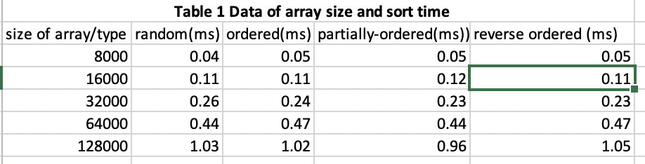

* 1. Graph of random array size vs. sorting time

* 1. Graph of ordered array size vs. sorting time

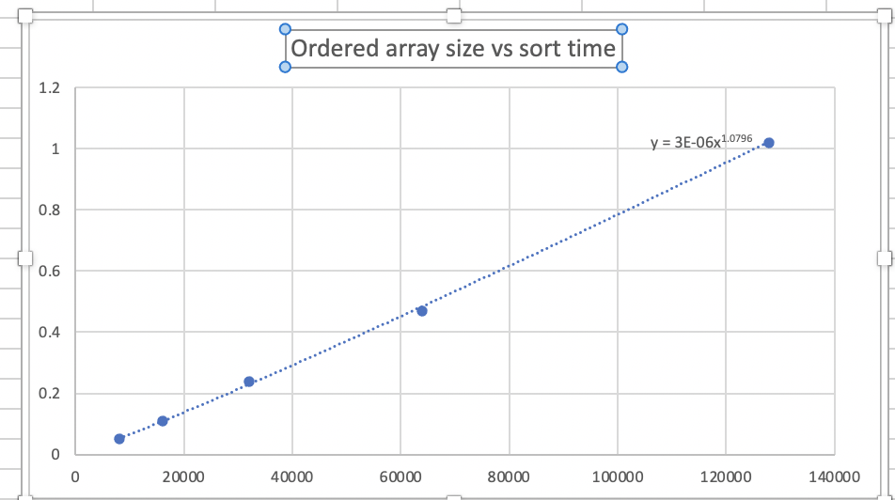

* 1. Graph of partially ordered array size vs. sorting time

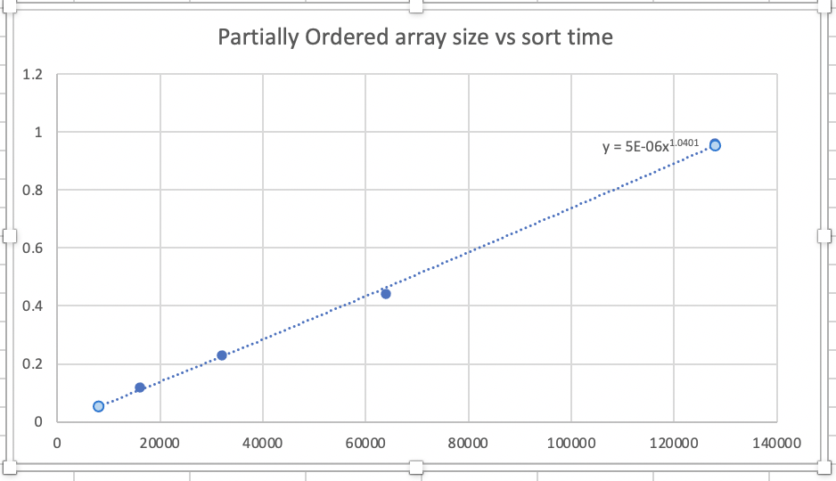

* 1. Graph of revered ordered array size vs. sorting time

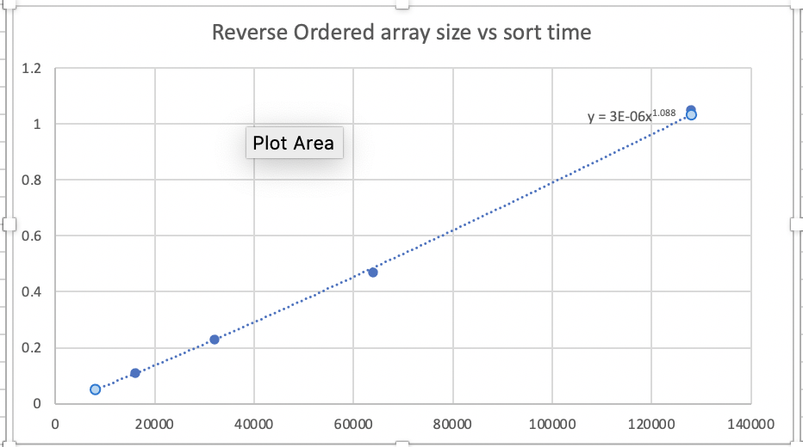

1. **Unit tests result:(Snapshot of successful unit test run**

Part 1:

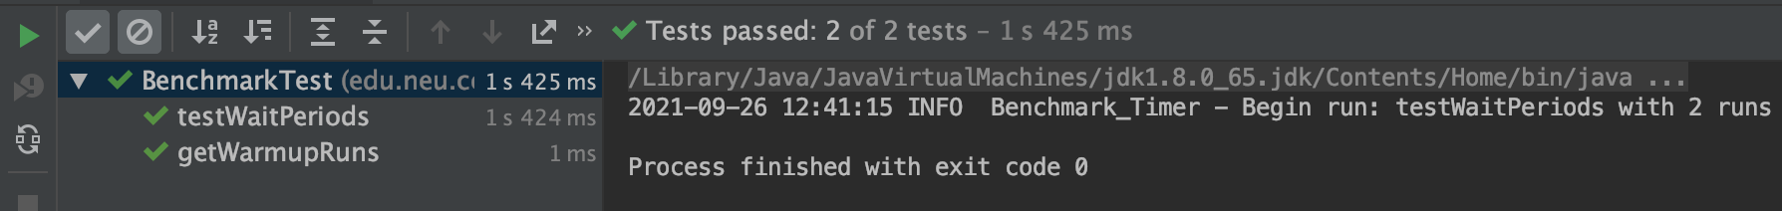

* BenchmarkTest all passed.

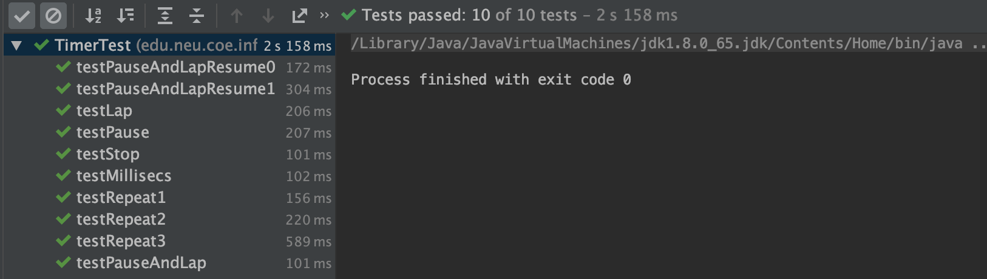

* TimerTest all passed.

Part2:

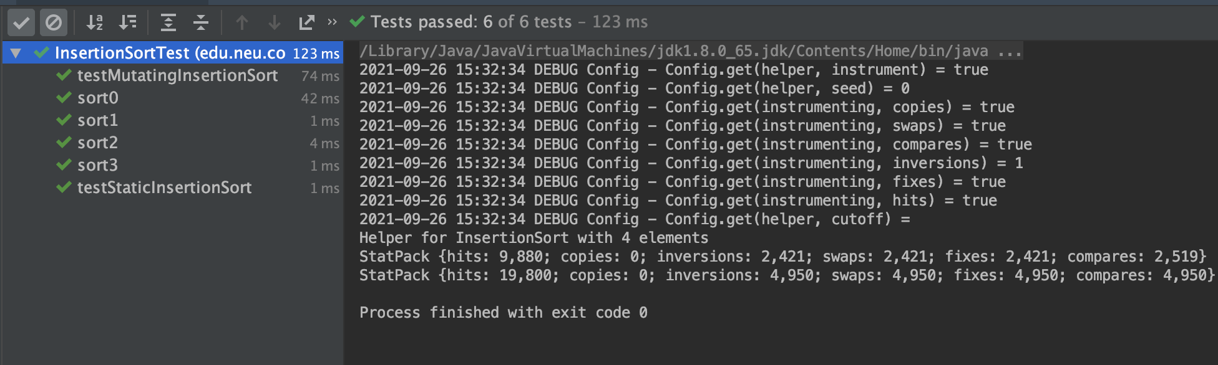

* InsertionSortTest all passed

Part3:

* Results shown above

Thank you!